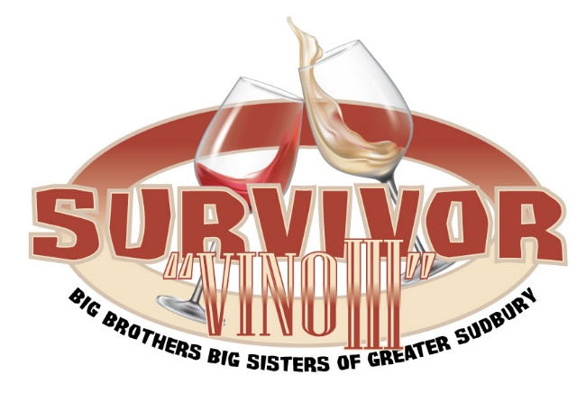

TEAM NAME: TEAM CAPTAIN:
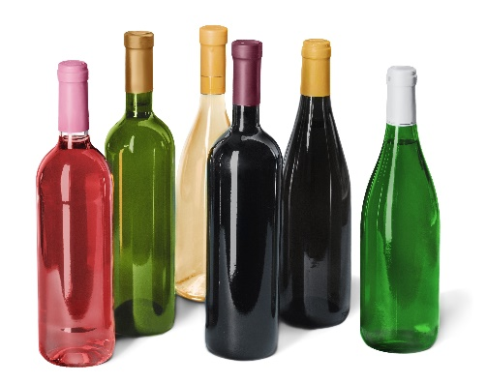
Phone Number: Address: Email:

Put a team together 6 people per team LIMIT OF 60 TEAMS!!!!
Each person pays $20 plus one $15 bottle of wine ($120 + 6 bottles/team) Registration closes: September 30th 2021. Draws begin October 4th 2021. All prizes announced by October 8th 2021.
The last 4 names will be awarded a whole lotta wine for their team!

Team Participants: (MUST BE 19 years and over)

 | Name | Phone Number | Mailing Address including Postal Code | Charitable Receipt?
1 |  |  |  | Yes/No
2 |  |  |  | Yes/No
3 |  |  |  | Yes/No
4 |  |  |  | Yes/No
5 |  |  |  | Yes/No
6 |  |  |  | Yes/No
We will assume you do not want a charitable receipt, unless you indicate otherwise.

You will be invited to join the closed Vino 3 Survivor Facebook Group once registered. Elimination will be done via our Facebook Group.
Payments taken by e-transfer chantal.gladu@bigbrothersbigsisters.ca Licence # M844601

BIG BROTHERS BIG SISTERS OF GREATER SUDBURY
224 Pine Street, Sudbury ON P3C 1X5 (705) 673-6161 sudbury. bigbrothersbigsisters.ca

WINE WILL NOT BE STORED ON
BIG BROTHERS BIG SISTERS PREMISES

